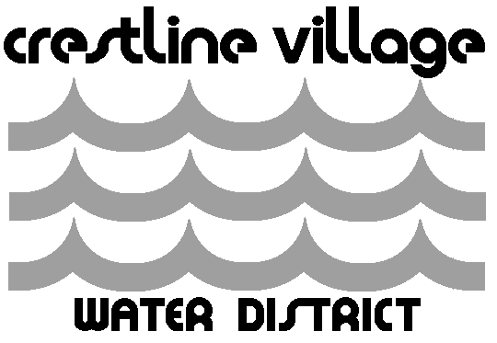

Memo

To: Board of Directors
From: Larrie Ann Davis
Date: July 31, 2026
Subject: Consider Changing the October 16, 2018 Scheduled Board Meeting

General Manager Clanin has a conflict with the October 16, 2018 Board Meeting. He will be attending an ACWA Human Resource Meeting in Rancho Cucamonga that day.

Director Stone also has a conflict as he will be out town.

Staff would like the Board to consider changing the Board Meeting date to October 23, 2018.

